Preliminary Design Report

Date 4/2/2019

Product Title: Sound Solutions

Team Members: Blake Morrell, Abdullah Alotibi, Charlie Carr, Josh High, Warren Bower, Chris Benjamin

Team Contact: Blake Morrell

**Introduction**

Sound Solutions is a new company that was founded by six EECS students at the University of Kansas. Our team is capable of creating a product that will accurately detect the loudness of sound. The JAWB2C6 seeks to provide multiple sound-related functions, yet the company’s first objective is to design a system that detects sound input and stores it as an integer value. From here, the user may pick how LEDs display the reading. When our team determines how to do this, the sky becomes the limit. Additional features we are considering adding at this point include volume comparisons, visual display, and picture games. The quality of the sound sensors caps our product’s potential, as creating a nuanced game will require a highly accurate decibel reading. Overall, the product blueprint allows flexibility in the design process. Once our product hits the market, we expect consumers to take interest in an inexpensive feedback device that assists anyone concerned with loudness. Our target audience includes choirs, bands, and orchestras. While our target audience is likely to take interest in the JAWB2C6, we believe that ordinary music listeners will consider our product to supplement their own stereo systems. Those who are deaf can experience music in a completely different manner. Avid gamers may find a good use of our product, as certain in-game sounds may tip off a player of their surroundings.  Sound plays a vital role in our society. The JAWB2C6 aims to expand the way humans look at sound.

**Embedded Systems**

The Arduino is the microcontroller for the system. It will be operating in conjunction with the sound sensors and LED display. The sound sensors detect an input, while the LEDs give the response.

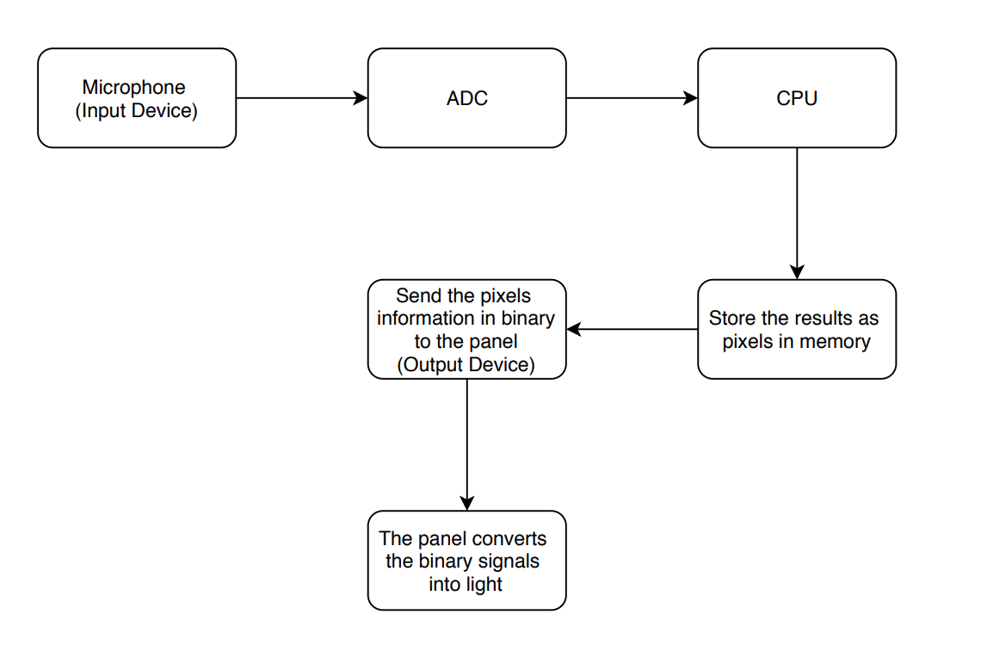

**Block Diagram**

**User Interaction**

The user emits a sound for the sound sensor to detect. Either the user or his/her environment can create this sound. Once the sensor reads the sound, it stores the value to be measured. Depending on the magnitude of the reading, a certain number of bars will appear on the Arduino. A higher reading means more bars, and a lower reading means less bars. This gives the user a visual of the reading’s magnitude. The user also has the ability to change the color of the display.

**Specifications**

A.      Microcontroller

|  |  |
| --- | --- |
| ARDUINO UNO REV3 | Specs: |
| https://lh3.googleusercontent.com/6lG38WsMPMPYwRCxSTikxH_5yalzqrNvcNnNFZEKhroJc_kGvdQGkmfWzfCQfnjqWTMK9HYIC7mZwNRgKZuz65DTbcEMyazjoW_wpeSXNafhmy54gylByocoVjIDlY6vIBFskfHC | Microcontroller        ATmega328P  Operating Voltage   5V  Input Voltage (recommended)         7-12V  Input Voltage (limit)   6-20V  Digital I/O Pins        14 (of which 6 provide PWM output)  PWM Digital I/O Pins 6  Analog Input Pins    6  DC Current per I/O Pin        20 mA  DC Current for 3.3V Pin      50 mA  Flash Memory 32 KB (ATmega328P) of which 0.5 KB used by bootloader  SRAM 2 KB (ATmega328P)  EEPROM     1 KB (ATmega328P)  Clock Speed 16 MHz  LED_BUILTIN       13  Length 68.6 mm  Width  53.4 mm  Weight 25 g |

B.      Sensor

|  |  |
| --- | --- |
| Sound Microphone Sensor Detection Module for Arduino AVR PIC | Specs: |
|  | Type: Logic ICs  1. AO, analog output, real-time output voltage signal of the microphone  2. DO, when the sound intensity reaches a certain threshold, the output high and low signal  Module features:  1. there is a mounting screw hole 3mm  2. the use 5v DC power supply  3. with analog output  4. there are threshold level output flip  5. high sensitive microphone and high sensitivity.  6. a power indicator light  7. the comparator output is light |

|  |
| --- |
| Sample Code for Sound Intensity Sensor:  //Digital Output:  int Led=13;//define LED interface  int buttonpin=3 //Define D0 Sensor Interface  int val;//define numeric variables val  void setup()  {  pinMode(Led,OUTPUT);// Define LED as output interface  pinMode(buttonpin,INPUT);//Define D0 Sensor as output Interface  }  void loop()  {  val=digitalRead(buttonpin);//digital interface will be assigned a value of 3 to read val  if(val==HIGH)//When the light sensor detects a signal is interrupted, LED flashes  {  digitalWrite(Led,HIGH)  }  else  {  digitalWrite(Led,LOW)  }  }  2.Analog Output:  int sensorPin = A5; // select the input pin for the potentiometer  int ledPin = 13; // select the pin for the LED  int sensorValue = 0; // variable to store the value coming from the sensor  void setup() {  pinMode(ledPin, OUTPUT);  Serial.begin(9600);  }  void loop() {  sensorValue = analogRead(sensorPin);  digitalWrite(ledPin, HIGH);  delay(sensorValue);  digitalWrite(ledPin, LOW);  delay(sensorValue);  Serial.println(sensorValue, DEC);  } |

C.      Actuator

|  |  |
| --- | --- |
| 32x32 RGB LED Matrix Panel | Specs: |
| https://lh5.googleusercontent.com/ut_MCtIgfuG76fyv4E17TSz48i0K84JfnEwOxD_Uw3eM5bb0bw6yws1MR4JGavjnglSf4WVBjZflmUbeciPuoxrEUQW-SFBm_jNmQXDU_BBXYVhEVNHM09GtZAps5Yy69IylXjkW | DATASHEET LINK:  <http://adafruit.com/datasheets/2026datasheet.pdf>   * Dimensions: approx. 160mm x 160mm x 14mm * Panel weight with IDC cables and power cables: 218.82g * 5V regulated power input, 4A max (all LEDs on) * 5V logic * 2000 mcd LEDs on 5mm pitch * 1/16 scan rate * Indoor display, 160 degree visibility |

**Tools**

I downloaded the Arduino Software IDE from <https://www.arduino.cc/en/guide/windows#toc1>. After downloading I simply ran the installer to install it onto my PC. The Arduino Software has several tabs, corresponding to their respective names. The tabs are Basics, Digital, Analog, Communication, Control Structures, Sensor, Display, Strings, USB, Starter-kit, and Arduino ISP. Looking through the details of the different tabs, I expect our project to use the Basics, Digital, and Analog tab mainly in our project.

**Parts List**

|  |  |  |  |  |
| --- | --- | --- | --- | --- |
| Item | Description | QTY | Cost | URL |
| 1 | High sensitivity sound microphone sensor. | 2 | $9.98 | <https://www.newegg.com/Product/Product.aspx?Item=9SIADG45WJ3684&ignorebbr=1&source=region&nm_mc=KNC-GoogleMKP-PC&cm_mmc=KNC-GoogleMKP-PC-_-pla-Keyboardmall-_-Gadgets-_-9SIADG45WJ3684&gclid=CjwKCAjwm-fkBRBBEiwA966fZEC8o6-vpV0QzzqAXYOBYf6zHDDXqnlK5SEm4KVeHnwxBnnXwqpgKBoC7u0QAvD_BwE&gclsrc=aw.ds> |
| 2 | Arduino Starter Kit Multi-Language | 1 | $87.90 | <https://store.arduino.cc/usa/arduino-starter-kit> |
| 3 | 32x32 RGB LED Matrix Panel | 1 | $44.95 | <https://www.adafruit.com/product/2026?gclid=CjwKCAjwm-fkBRBBEiwA966fZBwN-vrPxjhVXPU58zyZp3aIStk2zZHpo96FnMZIrr0yGDdXg84NYRoC7dEQAvD_BwE> |

**References**

Info parts for led display:

<https://learn.adafruit.com/rgb-matrix-featherwing>

Basic information and examples of how to work with an Arduino unit

<https://www.arduino.cc/en/Tutorial/HomePage?from=Main.Tutorials>

Link to code library for above part:

<https://learn.adafruit.com/32x16-32x32-rgb-led-matrix/>

Basically what we’re going for:

<https://learn.adafruit.com/assets/59612>

Arduino sound sensor (maybe):

<https://www.amazon.com/DAOKI-Sensitivity-Microphone-Detection-Arduino/dp/B00XT0PH10>

**Team Contribution**

Introduction (Blake)

Embedded Systems (Charlie)

Specification (Chris)

Tools (Josh)

Parts lists (Abdullah)

References (Warren)